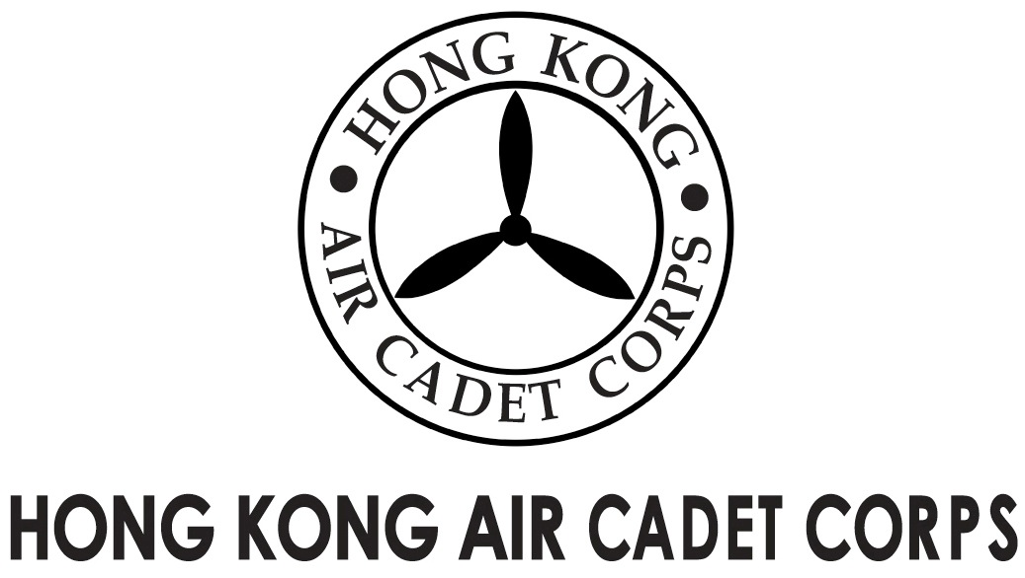
ADMINISTRATION AND SUPPORT GROUP.

From | OC PA Flt  (sakilee0906@gmail.com) | To | All OC Unit
Our Ref | GOSA/2018/1 | # of Pages | 2
Date | 11/11/2018 | Your Ref

Grantham Uniformed Youth Groups Outstanding Service Award
葛量洪青少年制服團隊傑出服務獎
Invitation for Recommendations

Introduction
The Grantham Scholarships Fund Committee (“the Committee”) is now inviting two nominations from the uniformed youth groups for the “Grantham Uniformed Youth Groups Outstanding Service Award” (“the Award”). The Corps will nominate two candidates to the Committee. To facilitate the nominations, we are now inviting OC No. 1, 2, 3, 4, 5, 6 and C Wg to recommend two potential candidates who qualified the selection criteria and are worth the honour. Two successful candidates among your recommendations will be put forward by a selection panel of the Corps through respective interviews.

Background
Each awardee of the Award will receive eight thousand Hong Kong Dollars. The results of the award will be announced by the Committee’s Secretariat in February 2017 tentatively.

Selection Criteria

    - Persons resident in Hong Kong who are pursuing local education;
    - Members of good character who demonstrate good leadership and strong commitment to the organisation;
    - All-round members who are both active in participating in regular training activities and are devoted in taking part community services;
    - Members have not been awarded the Award previously;
    - Members who are NOT above 21 years of age;
    - A cadet member for at least five years;
    - Members who have accumulated at least 200 service/training hours over the past 12 months; and
    - Candidates perform successful appearance before a selection panel.

Recommendation Procedures
OC Wings should submit the full names, rank, unit and serial no. of the nominees and each an essay of 500 or more words written by the nominee on a topic relating to either the training activity or the community service which they have participated in for assessment. Submission should be addressed to HQ copied to DCO Ops or DCO Trg (for C Wg) by 30/1/2018 1700 hour.

Selection Schedule

On or before 30/11/2018
all official recommendations should be submitted to HQ via emails
On or before 03/12/2018
candidates will be informed to attend a selection panel interview
On or before 12/12/2018
successful candidates will be announced
On or before 21/12/2018
two nominations of Corps will be sent to the Committee

Once again, thank you for your recommendations and facilitation. Please do not hesitate to contact the undersign by email or at 6088 5747 if you have any queries.

(signed on original)

Saki L W LEE
Flying Officer
OC PA Flt
sakilee0906@gmail.com

